LexTeach is a project by the Asian Association for Lexicography (ASIALEX https://www.asialex.org) to promote lexicography to the public through disseminating dictionary knowledge essential for users to understand how English dictionaries could support their learning and/or teaching of the English language. All the lectures and workshops of the projects will be delivered by ASIALEX members who have relevant expertise in the field. We hope to make dictionaries closer to their users so that users will have the know-how, and appreciate the value, of using them for their own purposes.
The first round of LexTeach will be offered on 18 and 19th of June 2022.
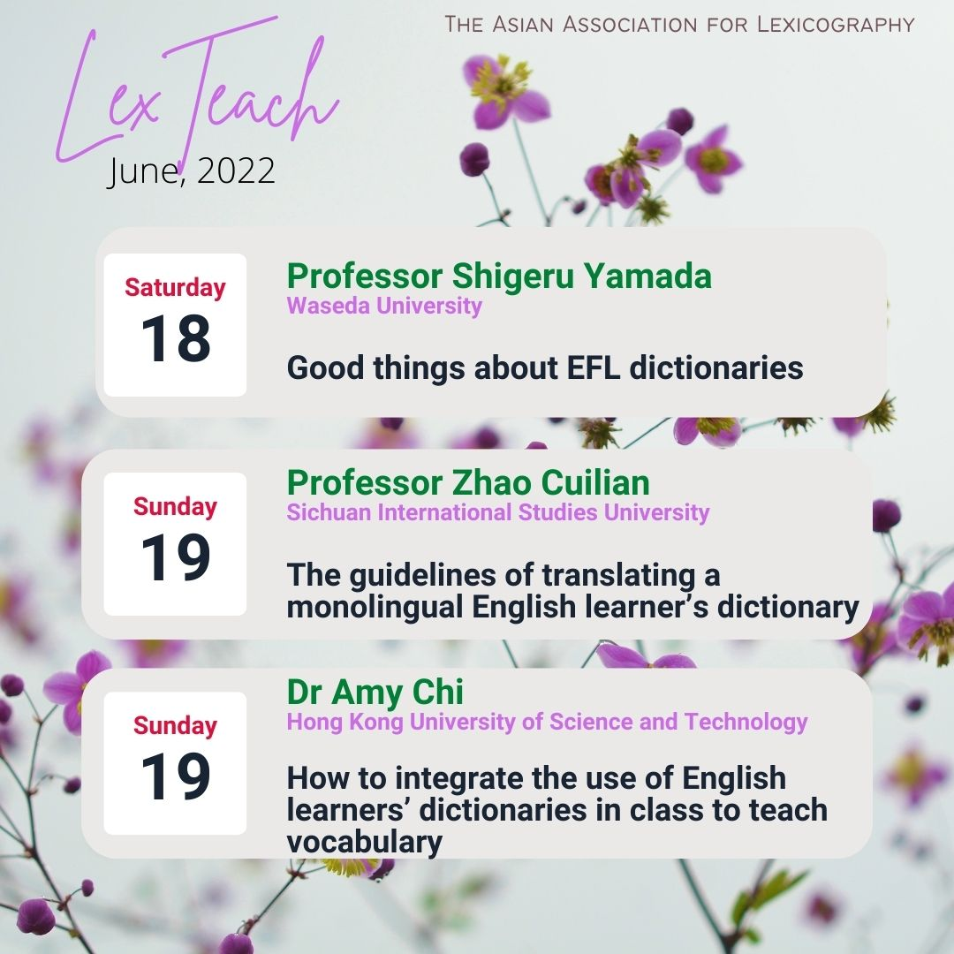
Who should apply: If you have been using one of the following dictionaries (The Big Six) and would like to know more about them, or you are a teacher who wants to teach your students how to use dictionaries to learn English:
Cambridge Advanced Learner’s Dictionary
Collins COBUILD English language Dictionary
Longman Dictionary of Contemporary English
Macmillan English Dictionary for Advanced Learners
Merriam-Webster Learner's Dictionary
Oxford Advanced Learner’s Dictionary of Current English

How to apply:
All details of the LexTeach 2022 are given in the registration forms (links on next page). Fill out the form of the lecture or workshop you are interested. Application is FREE and is offered on a first-come, first-served basis. The maximum capacity for a lecture is 100 participants, and a workshop is 30.

How to join:
Successful registered individuals will be sent a Zoom link, meeting ID and password for the designated event (details can be found on the registration forms).

Delivery format:
Lecture - Only the host and speaker can talk during the event. Other participants will be muted and advised to have their videos turned off. They can write either to the host or the speaker for questions or queries during the talk, or Q & A session.The talk will be video-recorded for dissemination.
Workshop – participants will be actively involved in small group discussions and activities. They need to unmute to talk and turn on their videos for effective interaction. The workshop will NOT be recorded.
LexTeach 2022 programme

Time suggested follows HKT. All the events will be delivered in English
June 18th (Saturday) | Time: 13:15-14:00 (45 mins)
Lecture #1  Speaker  Capacity:  100 participants | Professor Shigeru Yamada  Waseda University  Title: Good things about EFL dictionaries

June 19th (Sunday) | Time: 13:15-14:00 (45 mins)
Lecture #2  Speaker  Capacity:  100 participants | Professor Zhao Cuilian  Sichuan International Studies University  Title: The guidelines of translating a monolingual learner’s dictionary” 英漢雙解詞典編譯的特色  *Chinese may be used for illustrations

June 19th (Sunday) | Time: 13:15-14:00
June 19th (Sunday) | Time: 14:30-16:30 (2 hours)
Workshop  Facilitator  Capacity:  30 participants | Dr Amy Chi  Hong Kong University of Science and Technology  Title: How to integrate the use of English learners’ dictionaries in class to teach vocabulary

Registration links:
Lecture #1 https://forms.office.com/Pages/ResponsePage.aspx?id=4vMXySKTJkmbs9rKcwQTyihfcPWhpvFDuJpM4brZdX5UNFk5QzVPME1IMDVDUzVJOU9FNjNDT1g4Ti4u

Lecture #2
https://forms.office.com/Pages/ResponsePage.aspx?id=4vMXySKTJkmbs9rKcwQTyihfcPWhpvFDuJpM4brZdX5UQ0xVVFNaMUQ0U1Y4SzZaVTFLMFBLR0dQTC4u

Workshop
https://forms.office.com/Pages/ResponsePage.aspx?id=4vMXySKTJkmbs9rKcwQTyihfcPWhpvFDuJpM4brZdX5UMUEwVDk4VE1IOVdUUkJXQUczUjNZODNUWS4u

